ARTIFICIAL INTELLIGENCE

Mini Project Synopsis :-

Title page

1) Name : Aniket Warhade
Mis : 111903017
Email : warhadeab19.comp@coep.ac.in

2) Name : Abhishek Gaikwad
Mis : 111903006
Email : gaikwadad19.comp@coep.ac.in

3) Name : Anant Mhaske
Mis : 111903014
Email : mhaskeaa19.comp@coep.ac.in

Batch : T1

Proposed Topic:
Face Recognition based Attendance Management System

Face Recognition based Attendance Management System

Introduction:

- Traditional method of attendance marking is a tedious task in many schools and colleges. It is also an extra burden to the faculties who should mark attendance by manually calling the names of students which might take about 5 minutes of entire session.

- This is time consuming. There are some chances of proxy attendance. Therefore, many institutes started deploying many other techniques for recording attendance like use of Radio Frequency Identification (RFID) , iris recognition , fingerprint recognition, and so on.

- However, these systems are queue based which might consume more time and are intrusive in nature.

- Face recognition system consists of two categories: verification and face identification.

- Face verification is an 1:1 matching process, it compares face image against the template face images and whereas is an 1:N problems that compares a query face images.

- The purpose of this system is to build a attendance system which is based on face recognition techniques.

- Here face of an individual will be considered for marking attendance. Nowadays, face recognition is gaining more popularity and has been widely used.

- we proposed a system which detects the faces of students from live streaming video of classroom and attendance will be marked if the detected captured and stored in the dataset.

- During each session, faces will be detected from live streaming video of classroom. The faces detected will be compared with images present in the dataset.

- If match found, attendance will be marked for the respective student. At the end of each session, list of absentees will be mailed to the respective faculty handling the session.

The system architecture of the proposed system is given below :
System Architecture

Start Camera

Detection of faces
from live video
Live Streaming
Image acquistion

Start recognizer on
The detected face
Train the recognizer
With loaded training
set
Crop and Resize the
detected faces

Pattern Matching
Load the training set
for the recognizer
Store it in the
database

Mark Attendance
Email Notification

Feasibilty Study :

1. Reduces manual effort.

2. Keeps track of a student’s attendance correctly and gives the result.

3. Implementation of camera and sensors make this project totally automated.

4.Easy to be implemented in educational or commercial institutes.

5. Real time operations are done.

6.Images that are to be compared with the snaps taken by the camera can be easily stored in the database.

7.On the basic of this method, results such as defaulters list, students lecture wise n total attendance in percentage and count can be calculated and access to these results can be made available for teachers as well as students to keep track of their respective attendance.

Aims and Objectives
The objective of this project is to develop face recognition based automated student
attendance system. Expected achievements in order to fulfill the objectives are:
- To detect the face segment from the video frame.
- To extract the useful features from the face detected.
- To classify the features in order to recognize the face detected.
- To record the attendance of the identified student.
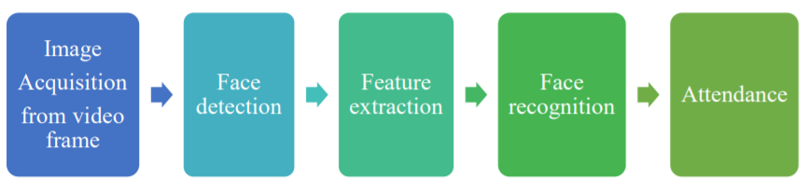

Literature Survey:

Arun Katara et al. (2017) mentioned disadvantages of RFID (Radio Frequency
Identification) card system, fingerprint system and iris recognition system. RFID card
system is implemented due to its simplicity. However, the user tends to help their
friends to check in as long as they have their friend’s ID card. The fingerprint system
is indeed effective but not efficient because it takes time for the verification process
so the user has to line up and perform the verification one by one. However for face
recognition, the human face is always exposed and contain less information compared
to iris. Iris recognition system which contains more detail might invade the privacy of
the user. Voice recognition is available, but it is less accurate compared to other
methods. Hence, face recognition system is suggested to be implemented in the student
attendance system.

# Advantages & Disadvantages of Different Biometric System (Arun Katara
et al., 2017)

System type | Advantages | Disadvantages
RFID card system | Simple | Fraudulent usage
Fingerprint system | Accurate | Time-consuming
Voice recognition system | - | Less accurate compared to others
Iris recognition system | Accurate | Privacy Invasion

Varsha Gupta and Dipesh Sharma (2014) studied Local Binary Pattern (LBP), Adaboost algorithm, local successive mean quantization transform (SMQT) Features, sparse network of winnows (SNOW) Classifier Method and Neural Network-based face detection methods in addition to Viola-Jones algorithm.
They concluded that Viola-Jones algorithm has the highest speed and highest accuracy among all the methods.
Other methods for instance Local Binary Pattern and SMQT Features have simple computation and able to deal with illumination problem, their overall performance is weaker than Viola-Jones algorithm for face detection.
Advantages & Disadvantages of Face Detection Methods (Varsha Gupta and Dipesh Sharma, 2014)

Face detection method | Advantages | Disadvantages
Viola jones algorithm | 1. High detection speed  2. High accuracy. | 1. Long training time.  2.Limited head pose.  3. Not able to detect dark faces.
Local Binary pattern | 1. Simple computation.  2. High tolerance against the monotonic illumination changes. | 1. Only used for binary and grey images.  2. Overall performance is inaccurate compared to Viola-Jones algorithm.
AdaBoost algorithm | Need not to have any prior knowledge about face structure. | The result highly depends on the training data and affected by weak classifiers.
SMQT Features and SNOW Classifier Method | 1. Capable to deal with lighting problem in object detection.  2. Efficient in computation | The region contain very similar to grey value regions will be misidentified as face.
Neural-Network | High accuracy only if large size of image were trained. | 1. Detection process is slow and computation is complex.  2. Overall performance is weaker than Viola-Jones algorithm

Research Gaps:
Face recognition is one of the most difficult problems in the research area of image recognition.
A human face is not only a 3-D object; it is also a non-rigid body.
Moreover, facial images are often taken under natural environment.
That is, the image background could be very complex and the illumination condition could be drastic.
Camera distortion and noise are standard variations in image recognition problems.
Evaluations of state-of-the-art recognition techniques conducted during the past several years, such as the FERET evaluations [7, 24], FRVT 2000 [25], FRVT 2002 [26] and the FAT 2004 [27], have confirmed that age variations, illumination variations and pose variations are three major problems plaguing current face recognition systems [28].

Methodology:

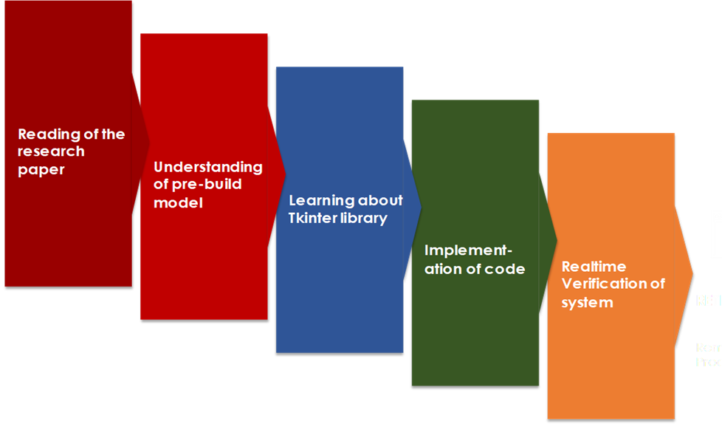

Facilities Required:
• Laptop/Computer with Camera.
• Windows/Ubuntu/MacOS operating system.
• Anaconda Navigator
• Jupyter Notebook
• Tkinter library

Timeline :
5 week project timeline
Week 1 | Research
Week 2 | Understanding of prebuild Model
Week 3 | Learning about tkinter library
Week 4 | Implementation of code
Week 5 | Realtime Verification of System

Bibliography:
Arun Katara, Mr. Sudesh V. Kolhe, Mr. Amar P. Zilpe, Mr. Nikhil D. Bhele, Mr. Chetan J. Bele. (2017). “Attendance System Using Face Recognition and Class Monitoring System”, International Journal on Recent and Innovation Trends in Computing and Communication, V5 (2).

Varsha Gupta, Dipesh Sharma. (2014), “A Study of Various Face Detection Methods”, International Journal of Advanced Research in Computer and Communication Engineering), vol.3, no. 5.

Sonia Ohlyan, Ms. Sunita Sangwan, Mr. Tarun Ahuja, “A Survey On Various Problems & Challenges In Face Recognition” International Journal of Engineering Research & Technology (IJERT) ISSN: 2278-0181 www.ijert.org Vol. 2 Issue 6, June - 2013

